Snort IDS/IPS Report with Rules

- Introduction
Snort is an open-source Intrusion Detection System (IDS) used to monitor network traffic and detect suspicious activity using predefined rules.
It works in three modes:
- Sniffer mode
- Packet logger mode
- Network Intrusion Detection mode

- Rule Structure
Each Snort rule has two main parts:

1) Rule Header
Contains:
- Action (alert, log, drop)
- Protocol (TCP, UDP, ICMP)
- Source IP/Port
- Destination IP/Port

2) Rule Options
Contains:
- Message (msg)
- Rule ID (sid)
- Revision number (rev)
- Conditions (content, flow, flags)
Intrusion Prevention System (IPS):
Unlike IDS, an IPS not only detects malicious traffic but also actively blocks it. Snort can be configured as an IPS by running it in inline mode using tools like DAQ (Data Acquisition Library). In this mode, Snort can drop or reject malicious packets in real-time.
- Requirements:
- Ubuntu Machine → Snort installed (IDS)
- Kali Linux Machine → Attacker/Test system
- Both should be on the same network

Snort(IDS) - Intrusion Detection System
- sudo apt install snort -y
- snort --version
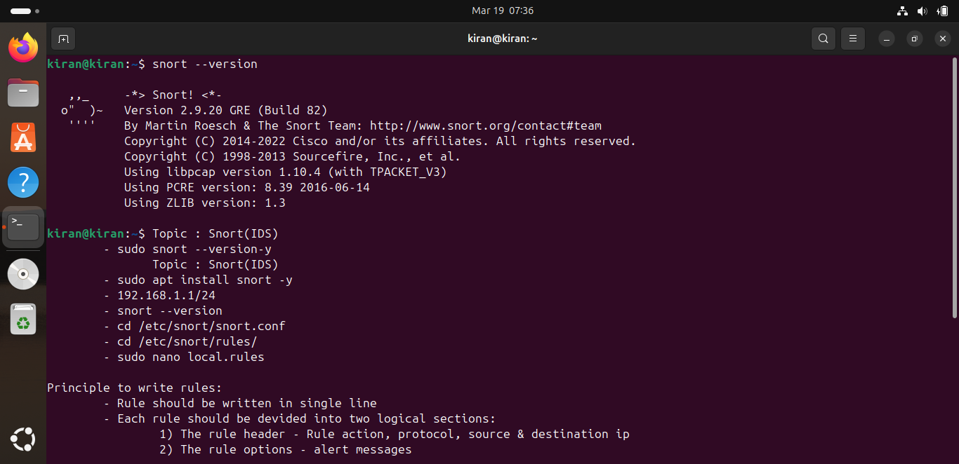
- cd /etc/snort/rules/
- sudo nano local.rules

- Rule 1: ICMP Ping Detection
alert icmp any any -> any any (msg:"ICMP Ping Detected"; sid:1000001; rev:1;)
- Rule 2: HTTP GET Request Detection
alert tcp any any -> any 80 (msg:"HTTP GET Request Detected"; flow:to_server,established; content:"GET"; http_method; sid:1000002; rev:1;)
- Rule 3: SSH Connection Attempt
alert tcp any any -> any 22 (msg:"SSH Connection Attempt"; sid:1000003; rev:1;)
- Rule 4: FTP Connection Attempt
alert tcp any any -> any 21 (msg:"FTP Connection Attempt"; sid:1000004; rev:1;)
- Rule 5: Telnet Connection Detection
alert tcp any any -> any 23 (msg:"Telnet Connection Attempt"; sid:1000005; rev:1;)
- Rule 6: DNS Query Detection
alert udp any any -> any 53 (msg:"DNS Query Detected"; sid:1000006; rev:1;)
- Rule 7: HTTP POST Request Detection
alert tcp any any -> any 80 (msg:"HTTP POST Request Detected"; flow:to_server,established; content:"POST"; http_method; sid:1000007; rev:1;)
- Rule 8: SYN Flood Attack Detection
alert tcp any any -> any any (msg:"SYN Flood Attack Detected"; flags:S; sid:1000008; rev:1;)
- Rule 9: Nmap Scan Detection
alert tcp any any -> any any (msg:"Nmap Scan Detected"; flags:S; threshold:type both, track by_src, count 20, seconds 10; sid:1000009; rev:1;)
- Rule 10: ICMP Flood Detection
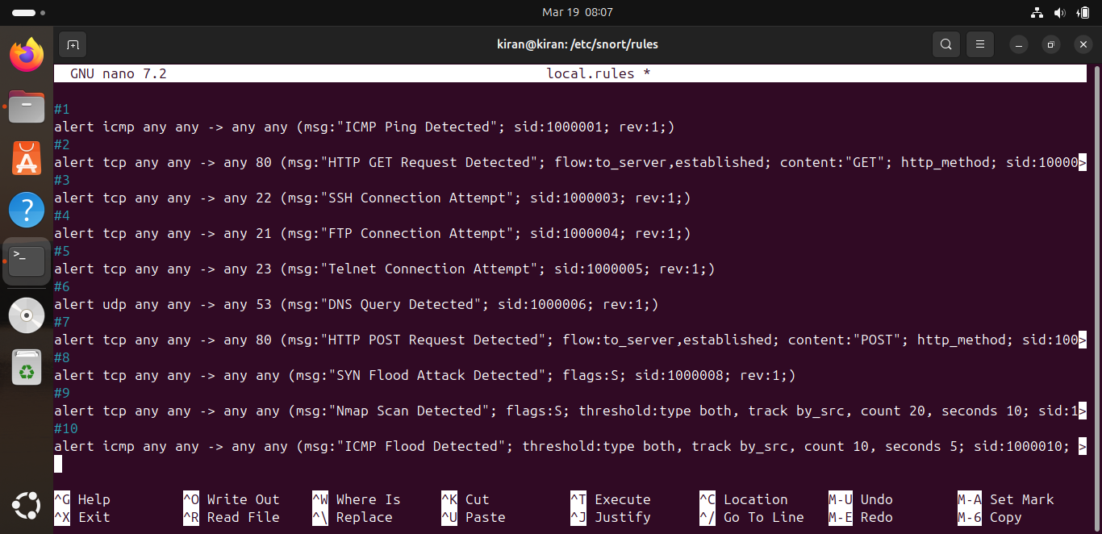
alert icmp any any -> any any (msg:"ICMP Flood Detected"; threshold:type both, track by_src, count 10, seconds 5; sid:1000010; rev:1;)

sudo snort -T -c /etc/snort/snort.conf
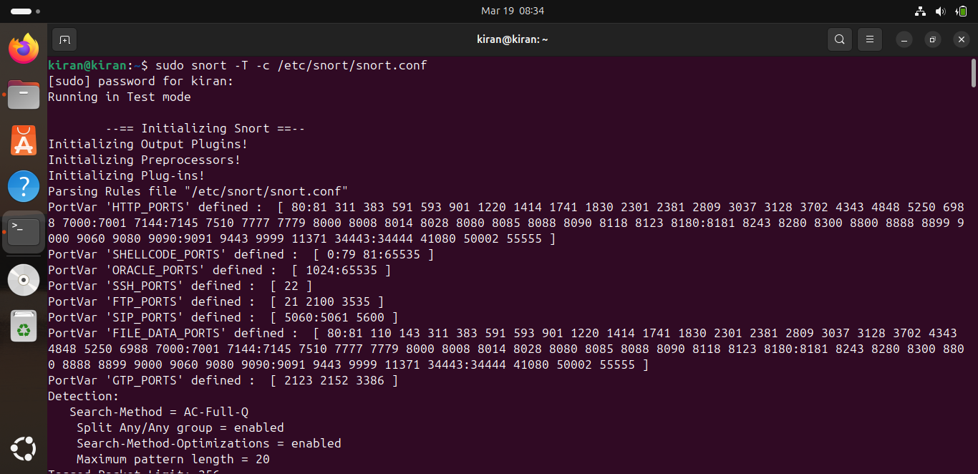

Start snort IDS-
- sudo snort -A console -q -c /etc/snort/snort.conf -i enp0s3

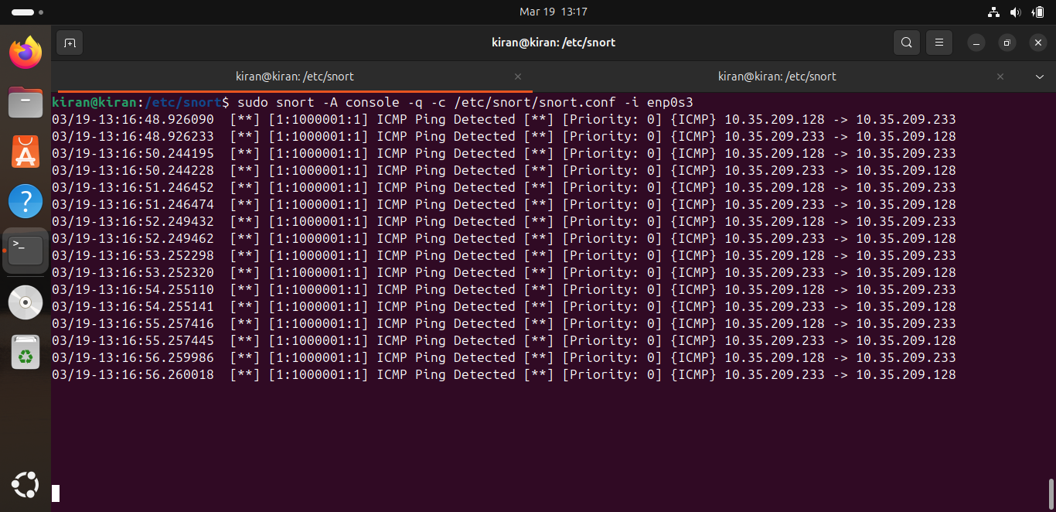
- ICMP Ping Detection

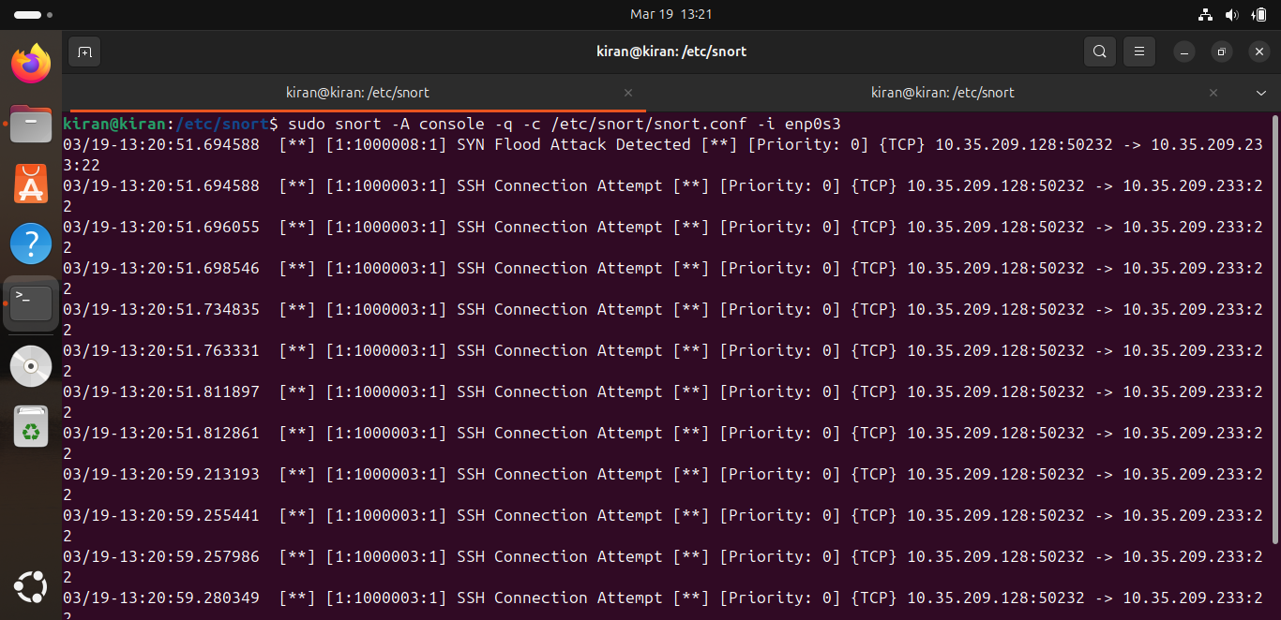
- SSH Connection Attempt

- FTP Connection Attempt
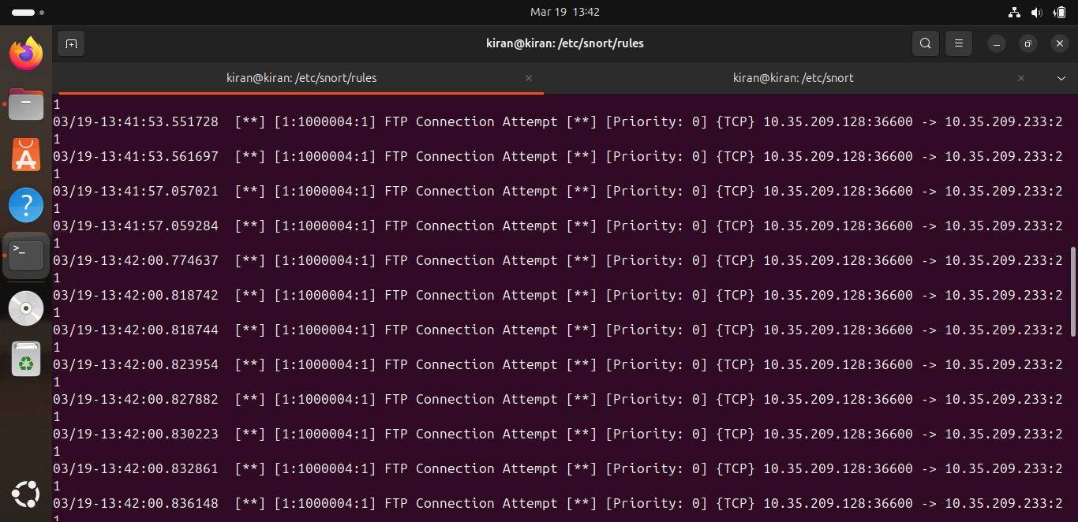
- Telnet Connection Detection
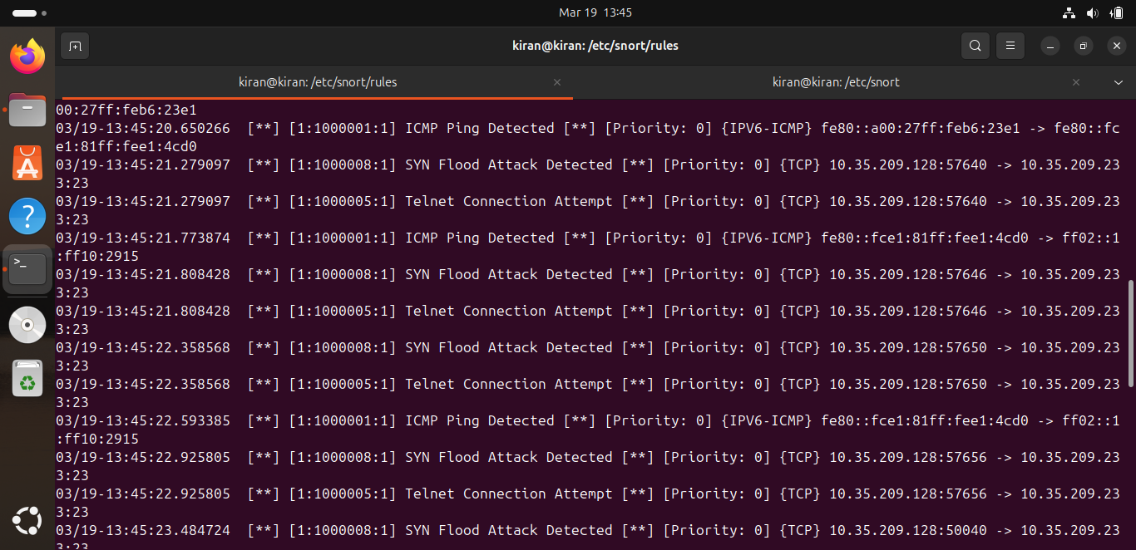
- DNS Query Detection
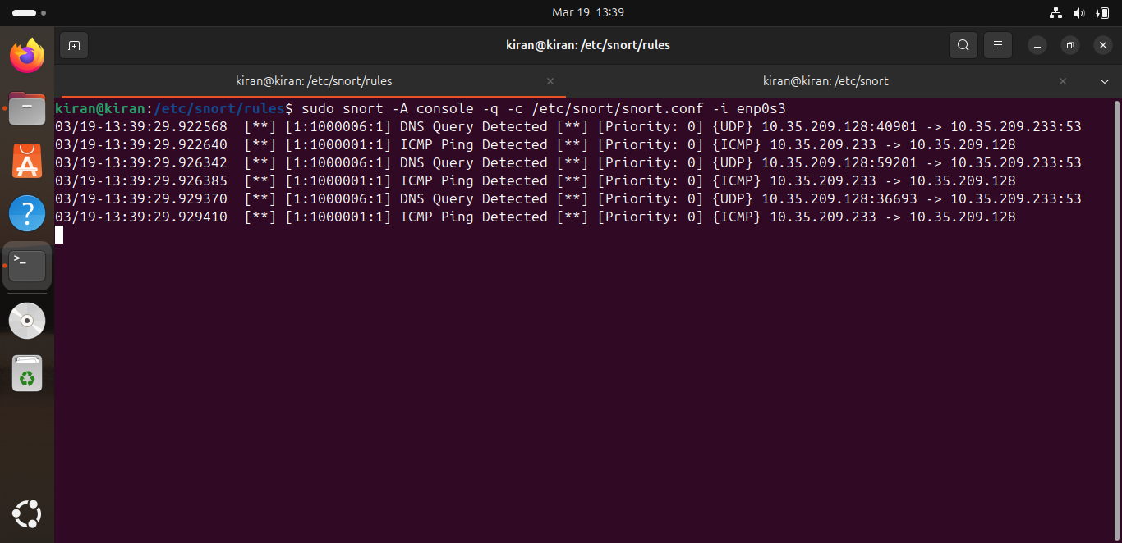
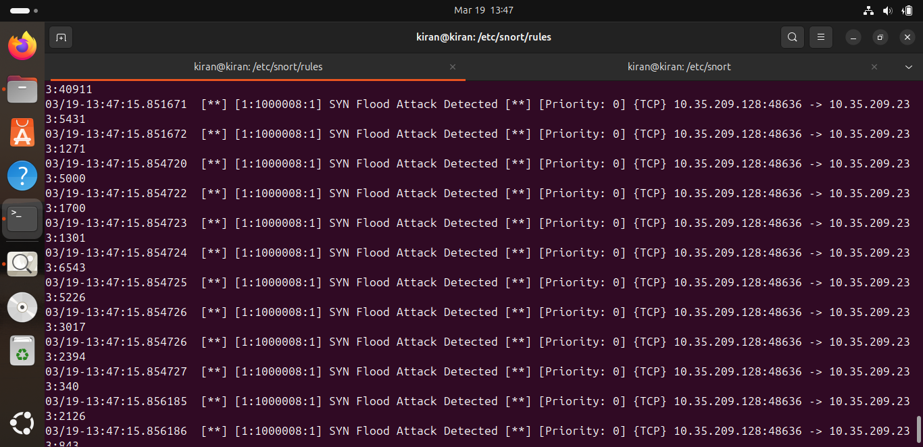
- SYN Flood Attack Detection

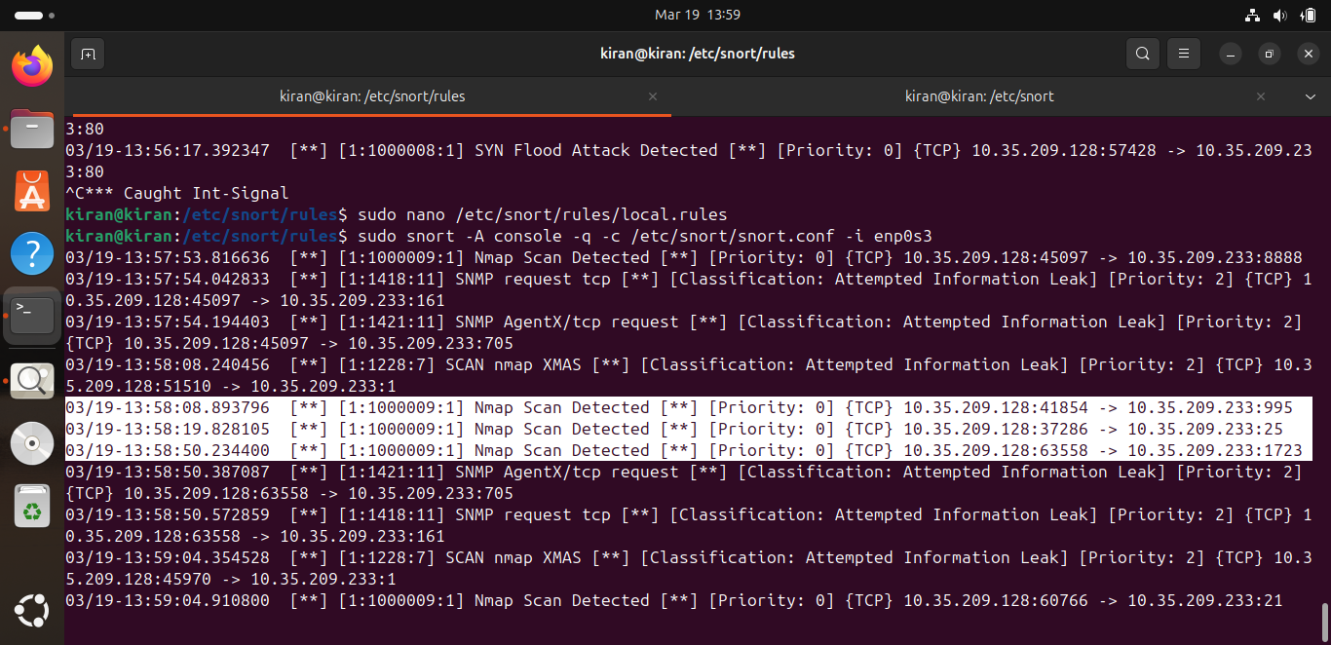
- Nmap Scan Detection

- ICMP Flood Detection
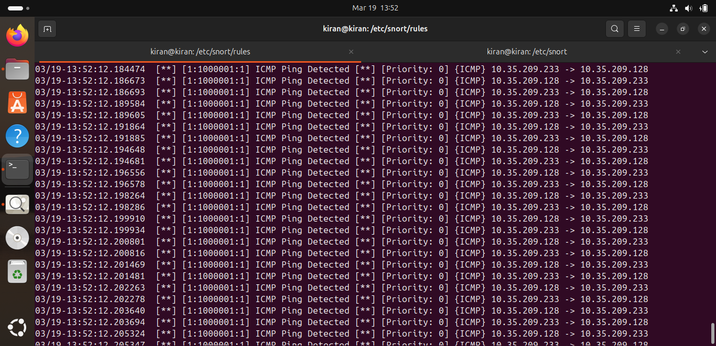

This enables Snort to block traffic instead of just alerting
- snort -Q --daq afpacket -c snort.conf -i eth0

Conclusion
Snort is a powerful IDS tool that helps in:
- Detecting network attacks
- Monitoring suspicious traffic
- Enhancing network security
By writing custom rules, administrators can:
- Detect specific attacks
- Monitor sensitive activities
- Prevent unauthorized access

